NUWC Golf League Rules 2023
The Rules of Golf published by the USGA will be followed with the exception of the rules and modifications for the league approved by the committee outlined below. The NUWC Golf League as a committee can adapt local rules and conditions of competition. See here for the 2019 USGA Rules: http://www.usga.org/content/usga/home-page/rules/rules-2019/rules-of-golf/rules-and-interpretations.html#!ruletype=pe&section=rule&rulenum=1

1.0 League Officers
President – Dave Nassaney | Web – Keith Casey
Vice President – Tim Clarke | Communication – Denise McCarthy
Treasurer – Glenn Donovan | Handicapper/Sub Manager – Pete Michno
Members at Large – George Bertsch, Dale Dandrea, Nick Decibus

2.0 League Team Format
The NUWC Golf League is comprised of 8 Teams for 2023.
2.1 Divisions - Each Team is divided into four divisions based on handicap. The four divisions are denoted as A, B, C, and D based on player handicaps. The slots may be adjusted as deemed appropriate by the Team Captain (see 11.F in Captains Duties) and in rare circumstances the President. View the “Teams” menu item on the website to view current teams.
2.2 Match Play - A match is played over 9 consecutive holes and consists of two individual matches per division with nine points per match at 1 point per hole (half for a split), combining for eighteen points per division.

3.0 – General Day of Play Information
3.1 Starting Holes – Most rounds will be started on the first hole at Green Valley. One week a month, Green Valley may start everyone on the back 9 off the 10th hole. During those weeks, the League will start on the back 9 as directed.
3.2 Tees – Men play from the white tees, ladies from the red and seniors from the gold. Gold tee recipients are typically made based upon physical handicap or limitations and the decision is determined at the discretion of the President on a case by case basis. Strictly speaking there is no specific age trigger for transition to the gold tees. The handicap for a gold tee recipient may also be adjusted down by two strokes initially as warranted by the President prior to a recipient’s first round being played. Requests to play from the Gold tees should be made directly to the President generally prior to the start of the season. After the start of the season, changing to gold tees will be adjudicated by the President on a case-by-case basis, with the expectation to play the rest of the season from the gold tees. (I.e. cannot switch back and forth).
3.3. Score Cards – Official cards published each week by the handicapper will have the holes for which each player is awarded strokes already marked on the card and available in the clubhouse prior to the start of the 1st match of the day. Strokes are awarded off the lowest handicap in each individual match. Men and women have differently handicapped holes. Go by the markings on the card. See Section 9.0 for additional information for Score Cards.
3.4 Slow Play – Ways to improve pace of play is an important topic not only in this league but the entirety of the golfing community as a groups pace (not speed golf) generally increases most players enjoyment of the game as it keeps a pace equal to the course recommendations (the front 9 at Green Valley should be played in 2 hours 10 minutes).
We have adopted a 40 second shot requirement (which includes, determining distance to target, selecting/swapping clubs, green reading). It should take no longer than 40 seconds for a player to play their shot once it is their turn to play, and safe to do so (consideration given to other players hindering the player, heckling not included). If a player is generally taking longer than 40 seconds on many/most of their shots, please notify your captain and let the captains discuss the issue with the players.
Ways to increase your awareness in improving pace of play (with apologies to Jeff Foxworthy):
- Go directly to your ball if you can and while other players are hitting in your group, or waiting for the group in front of you to clear, figure out your distances/range finder, wind direction, club selection, club cleaning WHILE WAITING. If you wait until it is your turn before you do any of the above, or you have to always be told “it’s your turn” because your imagination is running rampant, you MIGHT be a slow player.
- If you are sharing a cart, find both balls, get distances, club selection and if you can, drop one player off at their ball, and then move the cart to the other players ball. If you wait for one player to hit, then go to the other ball equidistant across the fairway, then you MIGHT be a slow player.
- If just finished the hole, you are at the next tee box of a course you have been playing for YEARS (you should know what club you generally use on 1, 2, maybe 3, 4, 6, sometimes 7, and 9), and you are never ready to go when it’s your turn, and you are constantly saying “why don’t you go ahead” or “aren’t we playing ready golf? Just go ahead!” a lot, you MIGHT be a slow player.
- If you always have to take more than 2 practice wings before you address your ball “Hello ball! I’m going to hit you now!”, you MIGHT be a…. no, you ARE a slow player.
- If you wait for other players to putt on the green before you even start to read your putt, you MIGHT be a slow player. Read the green while others are putting out, but without standing in front of, in back of, or ON their line.
- If you always have to backtrack to the other side of the green, or front of the green to get your stuff, and don’t place your cart/bag where you are going to exit the hole instead, you MIGHT be a slow player.
- If you are not waiting on the group in front of you to clear out if the way, if you are just going to your balls and playing without waiting, with a FULL tee sheet, you ARE a slow group and out of position. You need to pick up the pace. The pace of the group behind you is completely irrelevant, as they are going to be working to catch up to you and then see you have a gap in front of you.
- Mute your phone. No explanation needed.

4.0 NUWC Golf League Email Distribution List/Communication
The NUWC Golf League has an email distribution list to contact and inform players (both regular and subs) of league information.
4.1 Getting on the official NUWC Golf League distribution list – To get on the NUWC email distribution list, you must email the President or another league officer with your contact information (daytime phone and email). See “5.0 New League Players” for additional requirements.
Until you have been added to the official NUWC Golf League distribution list you will not be eligible to substitute in the league!
4.2 Getting off the official NUWC Golf League distribution list – To get removed from the NUWC distribution list, you must email the President or another league officer requesting to be removed. Your request will be forwarded onto the NUWC Website webmaster and subsequently removed at which point you will no longer receive any further league emails.

5.0 – New League Players
Players wishing to play in the league as a regular or a sub will have their starting handicap adjudicated in one of two ways:
- (Verifiable) Players can provide verifiable proof of handicap by GHIN or similar service, or provide results from another league when asking to join the Distro List and the league will use that handicap.
- (Not verifiable) After being added to the Distro List and absence of verifiable proof above, will, on their first round of play with the league, be assigned a “99” as a handicap. (99 is simply an identifier to calculate a players handicap prior to entering the cards in the system and is not an actual starting handicap). After the round, an average of all players handicaps that took the same strokes (+/- 1 stroke) will be the new players starting handicap for the league. Example: If the new player shot a 50, all handicaps of players shooting 49, 50, and 51 will be averaged. If the substitute's score significantly increases or decreases in the next or subsequent round(s), the President reserves the right to adjust the handicap and also possibly rescore previous matches if required.

6.0 Teams
Each match consists of four players, two each from the same division of scheduled opposing teams.
6.1 – Fielding A Complete Team - Each Team should field one regular Team member per division. Captains should consider placing Team members in appropriate divisions to field a proper Team where the handicaps are closely matched as to avoid disproportionate handicaps (giving too many, or too few, strokes to an opposing team). Exceptions to this rule, e.g. two subs playing as a Team, will be justly adjudicated by the President at the time of roster submittal (President should be notified of the situation as early as possible for guidance). The captains should provide their roster as early as possible to the handicapper and no later than noon the day before play.

7.0 Schedule / Points
League matches will be held on Thursday afternoons at Green Valley with tee times beginning at 2:30pm.
There will be a twenty four (24) week season divided into two 12 week halves. The schedule is balanced as well as it can be with varied starts and division (‘flight”) orders. With 24 weeks, every team will play each other 3 times, but some will only play 1st half, some will only play 2nd half. *Only way would cold figure out 24 week schedule.
We also changed flight orders, so please pay attention to tee times this year. We randomized them with an exception of the last week due to scoring needs in the clubhouse after the round. There are also no bye weeks this year. See the ‘Tee Times‘ page for the weekly schedule.
If a rainout occurs, it will NOT be made up. No points are accumulated for rainouts. See Weather Rule 14.0 for more details.
Winners of each half will meet in the championship at the end of the year. After each round, points reset. See Championship for more information.

8.0 Substitutes (Subs)
Subs are allowed during normal league play. Subs are not allowed for the League Championship. Finding a sub will be accomplished through the NUWC Golf League website or via captains/players looking for subs.
Filling in to be a sub is done strictly on a first come first serve basis through the website using the Sublist > I Want to Sub menu items. The password for access is sent in the daily request for subs email.
If/when a sub is needed, he/she will be positioned in the logical division as determined by the Team Captain if needed, but usually people do play in slots they sign up for through the website.
How it works…
When someone goes to the website to claim one of the available tee times, the request is recorded in the website and the captain and the league handicapper will update their roster so the scorecards can be generated correctly. It’s that easy when you use the website for subs.
All URLs managing this feature password protected to prevent outside parties such as hackers from flooding the site. Captains will receive a different password via email to support managing of your team.
Each team member is responsible for finding substitutes for any week they cannot play. Failure to do so as early as possible will put YOUR Team in a bind. Those needing a substitute MUST inform their team captain either verbally or via email in addition to requesting on the website. Hey, it’s just good manners.
Substitution requests are encouraged through the NUWC Golf website. Those needing a sub can post their information, and the players wishing to sub can review the available slots. Emails will be sent each morning announcing slots may be available for the week about to be played. Those willing to take the available spot can go the website to claim the open spot.
Team captains will go to the website to view still available and filled slots. Of course you can still arrange for a substitute outside the website, but you MUST notify your Team Captain as to who the substitute you’ve secured is. In this case there is no need to post a request for a substitute through the website. If a request is made for a sub on line, and it was filled by other means than the web page, it is up to the requestor or the Captain to fill in the name of sub and accept. This is to avoid two players showing up for the same slot.
A. Requesting a Substitute – If a team member needs to request a substitute for any upcoming week, they can go to the website (the link is distributed daily through email), fill out the necessary fields (Date Needed, Tee Time and Team Number) and click on the ‘Request Sub’ button to post the request for a substitute. This will add the open tee time to the list of available tee times displayed on the website. Cutoff time for submitting a request for a substitute on any given week is 1100 on the Thursday of the week being played. At any time from this page you can also go to the page which displays the available tee times that week by clicking on the ‘Sub Listing’ button. Remember to notify your captain via email.
B. Wanting To Sub - Subs wanting to play on any given Thursday should visit the website at (the link is distributed daily through email) and press the “I Want To Sub” link to view the slots available for substitution. Note that individuals who know they will be on TDY or vacation can plan ahead and post the need for a substitute for any date in the future. Thus you can accept the tee time weeks in advance if you wish. Simply select the ‘I Will Sub’ button for the appropriate available tee time shown in the list.
After selecting an available tee time, you will be brought to another form which prompts you to enter your name, handicap (if known). Submission is completed by clicking on the ‘I Will Sub!’ button. Remembering your handicap is not required to substitute, unless it is the first time you have substituted in the league.
Availability of tee times are handled on a first-come-first-served basis and managed by the website. Given the nature of web transactions, there is a very small possibility someone else could book the tee time before your acceptance is processed. If this occurs the website will let you know it’s rejected your request. When this occurs, try clicking on the ‘Sub Listing’ button and selecting another available tee time instead. Acceptance of the tee time by the website will remove the tee time from the list of available tee times displayed. Team Captains are responsible for going to the Captains Corner of the Website to occasionally view available and taken spots.

9.0 The Score Card
All cards will be filled out with match and team assignments and the tee times and will be available at the GVCC pro shop desk prior to the start of the 1st round of the week.
The last person in the group to arrive should always pick up the card and take it to the tee. If you’re about to tee off and someone is missing, head back to the pro shop and get the card to start your round. The person missing will either catch up, or will be scored as a noah showupa. (See scoring to find out what to do here).
Don’t be late for your tee time!!!!!!!
9.1 – Assigning Handicap Strokes - Strokes are assigned on the card based on the lowest handicap in the match. Remember, there are two matches per division so A vs B may have different strokes than C vs D.
The lower handicap golfer in the pair does not receive strokes. Higher handicappers only receive the difference in stokes between themselves and their opponent. The stroke differential is distributed across the holes on the 9 holes being played according to the Stroke Index or the ‘Handicap’ rating of each hole on the course as seen on the provided score card below. Remember, some weeks the league goes off the back, so the handicap ratings will be different compared to the front 9. For example, if Player 1 has a 3 handicap, and Player 2 is a 7, the correct card is annotated with the appropriate number of strokes for each player in below (Player 2 receives 4 strokes distributed to the 4 hardest holes). Differential strokes are awarded to the holes with the lowest handicap index remaining until all the strokes for a player have been accounted for.
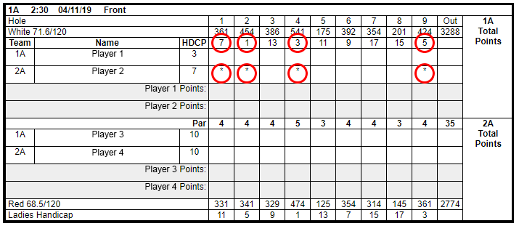
When the differential strokes exceed 9, additional strokes are awarded continuing at the lowest handicap index hole. Thus Player 4 (Substitute) in the card below receiving 11 stokes will get two strokes on the numbers 1 & 3 handicap holes on the card which happens to be holes 2 & 4 in the example.
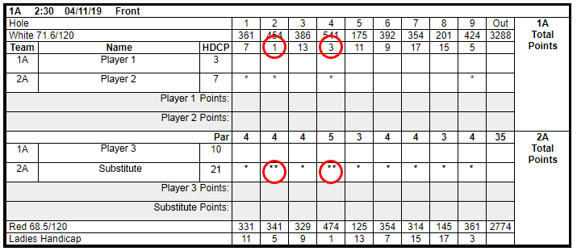
To determine a players net score, the number of strokes annotated on the card for the given hole is subtracted from his gross score which is written on the card.
Also note, if there is a lady in your group she will play from the red tees. Men and ladies have different handicaps on different holes. Those playing from red tees will have different handicap holes than those playing Gold/White. Please pay attention to stroke holes. You must use the handicap values on the BOTTOM of the card “LADIES HANDICAP” for ladies.
9.2 Missing Player (“Noah Showupa”) or Last Minute Subs - There are times where a “Noah Showupa” may be in the match (or a last minute sub has been found after the cards are printed).
9.2.1 Noah Showupa – If one division has only one player for their side and their partner does not show, the single player will be playing 2 one-on-one matches. Copy the strokes taken by the available player on each hole to the other half of the card for the missing player, adjust the handicap strokes for the other match (See 9.1 above), and score accordingly.
If only one player in the same division from scheduled opposing teams play (one noah on each side), the match is still played, however points are doubled, 2 points instead of only one per hole. Be sure to adjust handicaps accordingly as in 9.1. above.
9.2.2 Last Minute Sub – If a last minute sub is available to play in the place of a noah, hail a league official or any captain to access the players handicap from the League Website. Use that handicap to adjust the handicap strokes for the other match accordingly (See 9.1 above) before play. If that was not possible prior to the beginning of the round, record the strokes taken, but do not score points for that particular side. It can be done following the round after ascertaining the subs handicap.
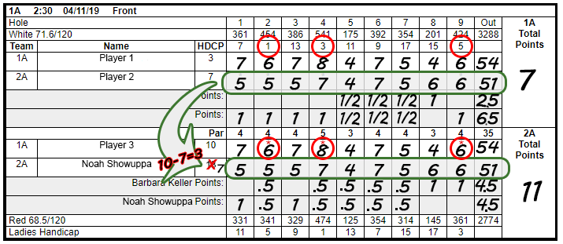
9.3 Points. - A match is played over 9 consecutive holes and consists of two individual matches per division with nine points per match at 1 point per hole (half for a tie), combining for eighteen points per division. Only one player will have NET strokes per individual match, if any. Gross score is the number of actual strokes taken by a player. NET score is gross stokes minus NET strokes given to the player (number of asterisks on the card). The lowest NET score per hole gets one point. If NET scores are tied, the hole is tied (“.5” or “1/2”). The scorer for the group can choose to fill out the “ties” by recording either “.5” (bottom half of figure) or “1/2” (top half of figure), although .5 is easier to read and will not be confused with “1”. Once all holes are played, add team points together and note in right side of card. (2.5 + 4.5 = 7 / 6.5 + 4.5 = 11).
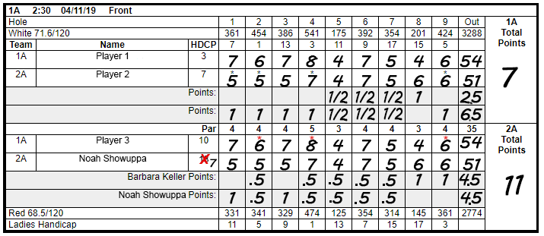
9.4 – Questions on Scoring. Any question of scores/strokes taken on the card by player(s) should be completed by the playing group and before the card is handed in to the officials. At the end of the match, the scorer will initial the card. A player from the opposing team will also attest to the score and initial the card. This is very important as cards will only be considered official and final once initialed/signed and dated and turned in to an official for scoring. Once this is done, the cards can be turned in to the handicapper or any league official in the clubhouse immediately upon completing the match. If the handicapper or a league official is not present in the clubhouse, there is an envelope located on the GVCC bulletin board to drop off your card. Once the card is turned in, the only question by league officials may be legibility, in which the officials will try to determine the proper strokes taken.
9.5 – Scores. Scores will be entered into the NGL Website scoring system hole by hole, online. Make sure the numbers are clearly identifiable and legible before handing in to minimize any question on scores per hole.
Green Valley Country Club will allow additional play after league play on a not to interfere basis.
9.6 – AFTER THE ROUND/Handing in card. Make sure to sign your card and hand in to a league officer in the 19th hole after your round, and BEFORE going out the back 9 if you do, or leaving the property. If you are one of the 1st few groups out, and no league officers are in the 19th hole, place it in the envelope on the wall in the clubhouse hallway marked “NUWC Golf league”.
Envelope is not to be used after 5:30pm (1.5 hours after last tee time), as there will be NGL members inside/on deck to give the card to. Any cards put in the envelope after 5:30pm, or if you went out on the back 9 without turning in, will lose 2 points each per team/flight (it’s a group responsibility, not just the individual that has the card).

10.0 Handicaps
Each returning member will start the year with a handicap based on last year’s (or previous years if not playing as often/subbing, etc…) average of all played rounds ((average of adjusted scores-35.5)*.96). This includes returning substitutes. New members and substitutes will start as described in 5.0 “New League Players”.
10.1 Handicap Calculation After 1st round for season -
– The last five adjusted scores plus the current week’s adjusted score is ranked. (For the 1st five rounds, we use your starting handicap + par, rounded, as scores for the weeks not yet played, and continue to drop the highest until you have played 5 rounds.)– The highest score of the size is dropped and the remaining five are averaged.
– The course rating of 35.5 is deducted from this average and 96% of the difference is your new computed handicap.
– Max handicap is capped at 27. Any handicaps exceeding this limit on a weekly basis will be adjusted to 27.
– The adjusted handicap (“ADJ”) column in the weekly results is based on the playing handicap for that score, where each hole’s score is examined and adjusted for a maximum limit. Values exceeding this maximum limit are disallowed. The maximum limit is following 2019 World Handicap System and is set at Net Double Bogey. See: https://www.usga.org/content/dam/usga/images/handicapping/Net%20Double%20Bogey%20is%20the%20new%20Max%20Hole%20Score.pdf

11.0 Captain’s Duties
Captains have been designated by the League Officers and are indicated by highlighting on the Team rosters. A captain’s duties are important!!!
What are the captains duties?
A. Every Thursday, the Handicapper will fill out the score cards for the matches after he/she receives inputs from the Captains.
B. Captains should call/e-mail the handicapper no later than 1100 Thursday to give their line-ups.
C. Team Captains should appoint a Team member as a substitute Captain in case of absence. Substitute captains should be given the Captain’s management URL (which captains will receive in a separate document) in addition to those included herein to manage their team during their absence.
D.. Unconstrained selections of long term substitutes are not allowed in order to be fair to those awaiting a regular slot. If captains are having a hard time finding a sub, contact the league President and start emailing players from the sub list (Captains Corner of the website).
E. Slow Players – Captains have the responsibility to coach slower players and notify them when their play has become a hindrance to others enjoyment of the game. Players should go directly to their ball and while waiting, figure out which club they wish to use, get distances, etc… We have adopted a 40 second shot requirement: From the time it’s clear for the next player to play a shot when it’s their turn to do so, and clear to do so, it should take no longer than 40 seconds from their turn to start their process, to hitting the ball. Times longer than that, and players (or their captains) should be notified.
F. Reallocation of Players – Captains at any time should consider players on their teams to be grouped according to handicap. Players doing well on flights may garner consideration to move up flights, while players that have slipped may be considered to move down flights. This keeps the playing field and matches more level and fair.
Leveling the handicaps/players can be done at any time. Captains are dissuaded from doing it week to week, but if the handicaps start to trend higher or lower per flight leaving unbalanced flights, then the captain should take action. Example; a player on your B flight jumps from 10 to 14 after a couple weeks, and someone went from a 15 to a 12 on the C flight. The captain should consider the players history, and consider swapping the 14 hdcp and the 12 hdcp players/flights if they may appear to hold the handicaps. All changes must be approved by the president.

12.0 Attendance/Forfeits
A forfeit occurs when both players of a single division on the same team do not play. Any Team that forfeits a division match will not receive any points (0) and opponents will be automatically given twelve (12) points. Forfeit time is when the last scheduled tee time (typically 4:30pm) from the assigned tee has left the tee box for the hole. There will be a starter at the tee. If any member of your foursome is late, the players that are there may decide to let other foursomes tee off while they wait, or you may decide to tee off as scheduled. Holes played during any time an opposing player is missing, will be scored as 2 v 1, or 1 v 1 if the case may be. Tee times work out really well, so there are very few good reasons for being late. If you have a problem, call your partner or your captain or the Club House and let someone know.
Anyone who fails to show up for two times without notifying their captain beforehand will be removed from their Team and replaced by the next person off the Sub List.

13.0 Dues
League dues for regulars are due no later than COB May 11th, of the current league season which affords individuals almost 4 weeks from the beginning of the season to become compliant. Payment can be made to any league official at any time.
League dues will be $50/year, payment must be received by May 11th. Payment increases to $55.00 if received after May 11th. Members are responsible for paying their own dues. Payments can be made to Glenn Donovan, Treasurer, to your Team Captain, or to any other League Official.
After May 18th penalty points will be assessed against each team with still delinquent player(s) at a rate of 2 penalty points per delinquent player per week. Accordingly, points will be deducted off the team’s point total every Thursday after 2000 (starting May 11th) until all players are paid in full. To that effect any player who is in arrears after May 18th will be replaced by someone off the sublist so as not to unduly punish the remainder of the team. We want to be fair, but we also want committed players in the league.

14.0 Weather/Postponements
Cancellations will be justly determined by the President or his acting official on league days as close to 1200 as possible, and no later than 1330. He will inform Team Captains at that time. Captains will be required to notify their Team members. Will also be posted on the website as early as feasible. There will be no rainout rounds for 2023. The points earned are only for those weeks that were played. Weeks cancelled due to weather, everyone gets zero points for the week.

15.0 Etiquette
Please observe golf etiquette at all times and adhere to the rules of golf.
The President will resolve all disputes based on USGA Rules, what kind of mood he’s in, who the complainants are, what the moon is in, planetary alignment, etc. Let’s try to settle things on the course and not have a lot of whining over little, chicken-shit things. All disputes will be resolved by the President and may not be favorable… since he had to take time out of his day to ponder why you couldn’t settle it yourselves.

16.0 Championship TBD
16.1 Each match shall consist of 18 hole head to head matches between individual team members and their opponents from respective divisions.
16.2 The individual matches will be played at Green Valley on any agreed upon day and after the matchups have been agreed upon by the captains. These can be played together with division partners or separate, but will still be scored as individual head to head matches.
16.3 Captains/President may suggest scheduling to the players, however it is completely up to the individual competitors in the agreed upon match to schedule play due to differing schedules. (Earlier the better! Don’t wait until deadline only to have it rain.)
16.4 Captains shall ensure that they field a complete team with regular team players of similar handicaps from their respective divisions. Captains of the competing team must agree to the individual match line-ups. Substitutes are not acceptable. Line-ups will be provided to the President and Handicapper prior to the matches being played. Any disagreement, deviation or special circumstances will be adjudicated by the President.
16.5 Each player winning the hole will be awarded one point and the opponent zero points. Each player will score ½ point if the hole is tied.
16.6 The team with the highest total points will be declared the NUWC Golf Employees League Champion.
16.7 If the team Championship match results in a tie, the winner will be determined by the best total team score on the back nine. If a tie still exists, the winner will be determined by matching cards beginning with the A division lowest handicap players and the most difficult hole on the back nine, then the next most difficult hole on the back nine and so on until a winner is determined.
16.8 Any deviation or special circumstances not covered by the tie Championship rules will be adjudicated by the President.

17.0 Local Rules
17.1. Players will be notified if Lift-Clean-Place is in effect by the League President. Rolling the ball is not allowed anywhere on the course. We play the ball down unless Lift/Clean & Place is explicitly announced by President for a specific round and marked at the top of the cards. No lifting/placing out of footprints in bunkers unless there is a return to COVID rules (where it would be 1 club)…. Just don’t hit into them, right?
17.2. Players should always putt out when points for the hole matter, but if you have lost sight of the group in front of you and the team behind you are breathing down your necks, keep in mind that max score for handicap is net double bogey (par + 2 + dots on card). We suggest, if you start falling behind, pick up when you have mat/exceeded the net double and pick up the pace, and score the max for the hole.
ALWAYS give putts that don’t matter in the match (conceding putts/holes is LEGAL in match play) to help speed up pace of play for everyone playing behind you and the other side in your foursome. (Example: if your opponent is assured to get the point on the hole, including strokes, we are advising to pick up and move to the next hole - that hole has been lost and should be conceded. Do not continue to play the hole if you or your opponent concedes the same hole – pick up, move on). Be sure to announce your intention to your group that you are picking up and/or conceding the strokes so other the other players may continue play.
17.3. Ball Lost or Out of Bounds (Local Rule -Alternative Stroke and Distance) - When a player's ball cannot be found or is virtually certain to be out of bounds, the player may proceed as follows:
a. If your ball might be lost (not in a penalty area) or be out of bounds, to save time you may play another ball provisionally under penalty of stroke and distance from your location before you leave it.
But if you are aware that the only possible place your original ball could be lost is in a penalty area, a provisional ball is not allowed. If you play a ball from where the previous stroke was made (one option under penalty area rules, others are dropping near the extents of the penalty area), that ball becomes your ball in play under penalty of stroke and distance.
b. If you have already left the tee, or last place you hit from, for two penalty strokes, the player takes relief by dropping the original ball or a substituted as shown below: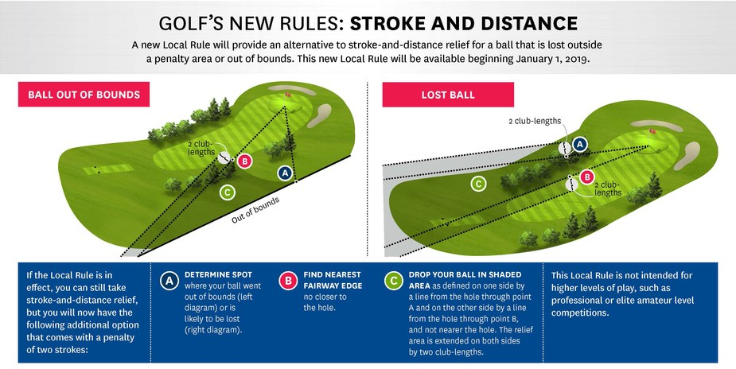

Example:
If you choose to use this local rule after your initial stroke off the tee box, you would be taking relief and lying 3, hitting 4. If your tee shot was in play and you hit out of bounds or have a lost ball on your 2nd shot, you’d be lying 4 hitting 5, etc., etc.
Once a player leaves the region where the original ball was last played, they forfeit the option to use stroke and distance relief (cannot go back to the tee or last spot hit from) and must proceed under the above ruling or any other applicable options - this includes removal of the stroke-and-distance option for all hazards.
Application case study:
Hole 3 - Tee shot goes into trees on right. You can hit a provisional by re-teeing and maybe being able to play your original ball, or drop up ahead using the new USGA guidelines of drop location options hitting 4. As soon as you leave the tee box area, you can ONLY use the new rule.
You now have 2 options when you hit a shot OOB/Lost/Unplayable area - use of stroke and distance (until you leave the original shot area) or the new 2-stroke penalty drop.
17.4 Provisional Ball - Players may play provisional balls. (See USGA Rule 18 for more: https://www.usga.org/content/usga/home-page/rules/rules-2019/players-edition/rule-18.html) If a player plays a provisional ball and the group leaves the tee box anticipating to play that ball, they may not return to the tee. They are to proceed under local rule 17.3 should the provisional be lost also, factoring number of balls lost. Example: Player hits a provisional ball and leaves tee box. Player cannot locate original ball nor provisional. Player MAY NOT return to tee. Player continues under 17.3, hitting 6 from fairway. (1 lost. 3 lost. Add 2 penalty strokes and hit 6 from fairway). Sometimes it may even just be better to concede the hole then and there, your call.
17.5 Closest to the pin - Each week there will be closest to the pin competition on hole #5 (or #12 if on the back).
Only shots that stop on the green with your FIRST STROKE count. If your ball measures closer than the best score that day, write your name on the score sheet with the measured distance.
A marker, name/distance sheet, pencil and measuring tape will be provided to the first group out (#1, 2:30 tee time). It is the first groups responsibility to place the marker on the green and leave it for future groups, or on the fringe/rough off the green, preferably on the back side of the green farthest from the tee box if no one in the 1st group made it on.
The last group to play the 5th hole is responsible for picking up the marker and bringing it in to the club house after league play, delivering it to a league officer. If no league officer present, take a pic of the card and text to league officer and hand in the marker to a GV Employee (usually in starter shack).
17.6 New course features – For 2023, the course has made some renovations that we noticed after week 1 and there have been questions regarding hedges (which are now gone) on Hole 3 and the man made items next to the 4th tee which now may be in play.
a. Until the ditch where the hedges used to be on the western dogleg of the third hole are filled in and have grass to play out of, the row of dirt will be treated as GUR. One club free relief, closest point of complete relief, no closer to the hole.
b. Farm equipment beyond 3rd hole and beside 4th hole and wood chips (considered garden) have one club free relief, closest point of complete relief, no closer to the hole.
c. Gazebo beyond 3rd hole and beside 4th has one club free relief, closest point of complete relief, no closer to the hole left or right of the entire structure. DO NOT play your ball through/under/over the gazebo. You get closest point of relief from it being in your way.
As a reminder of closest point of complete relief, please read:
https://www.usga.org/rules/rules-and-clarifications/rules-and-clarifications.html#!ruletype=fr&section=rule&rulenum=15
And watch: https://www.youtube.com/watch?v=vS3es7UOI8M

18.0 Waitlist
18.1 Each year, the League Officers solicit prospective members to join as either a regular or a substitute for the coming year. Based on responses, the amount of teams and format may be modified to ensure the league can maintain a balanced schedule and maximize regular player attendance. When this is done, the league may be required to select new regular members based on their ranking on the waitlist and/or also place a person desiring to be a regular player onto the waitlist. In order to make the determination of where the player is placed (e.g. regular or sub) at the beginning of the season, the prospective player ranking will be established as follows:
- For each week played in the previous season, the prospective regular member will receive 3 points towards his/her total.
- For each week played 2 years prior, the prospective regular member will receive 2 points
- For each week played 3 years prior, the prospective regular member will receive 1 point
- Prospective regular members that are NUWC Employees/retirees will receive an additional 10 points towards their total
- Prospective regular members that at any time in the past was a regular member will receive an additional 5 points towards their total
If a prospective player is new and has no history in playing in the NUWC Golf League, they will be prioritized as follows:
- A NUWC Employee/retiree based on order of response to the solicitation requesting players - All other based on order of response to the solicitation requesting players
18.2 There are times when during the season, a regular member is forced to remove themselves from being a regular member. When this occurs, a member will be moved from the waitlist and become a regular member based on their ranking on the waitlist. Once the season starts, the waitlist ranking will be adjusted on a weekly basis as follows:
- For each week played in the current season, the prospective regular member will receive 3 points towards his/her total.
- For each week played in the prior year, the prospective regular member will receive 2 points
- For each week played 2 years prior, the prospective regular member will receive 1 point
- Prospective regular members that are NUWC Employees/retirees will receive an additional 10 points towards their total
- Prospective regular members that at any time in the past was a regular member will receive an additional 5 points towards their total
18.3 All points are tallied at the end of the season to establish the waitlist ranking for the following season as described in paragraph 18.1. These rules have been put in place to make the selection process as fair as possible for the precious few spots which become available each year.

