NUWC Golf League Bulletin – 1st Half
Week #7
6 June, 2013

Place |  | Team |  | 1stHalf Pts | 1 | 2 | 3 | 4 | 5 | 6 | 7 | 8 | 9
1 |  | 9 |  | 275.5 | 40 | 41 | 36 | 44.5 | 36 | 41.5 | 36.5
2 |  | 3 |  | 268.5 | 36 | 36 | 41.5 | 39 | 36 | 40 | 40
3 |  | 5 |  | 265.5 | 40 | 41 | 36.5 | 35 | 38 | 39 | 36
4 |  | 7 |  | 256 | 47 | 31 | 30.5 | 39 | 34 | 38 | 36.5
5 |  | 8 |  | 252 | 32 | 42.5 | 31 | 33 | 42 | 36 | 35.5
6 |  | 2 |  | 248.5 | 34 | 31 | 41 | 27.5 | 36 | 34 | 45.5
7 |  | 6 |  | 245.5 | 25 | 36 | 35.5 | 37 | 44.5 | 32 | 35.5
8 |  | 1 |  | 231 | 38 | 29.5 | 35.5 | 36 | 27.5 | 30.5 | 32
9 |  | 4 |  | 226.5 | 32 | 36 | 36.5 | 33 | 30 | 33 | 26.5
Indicates Bye Week. The Bye Week team receives 36 points

Birdie (or Better)Report:

Birdie Report
Name | Hole Number
Schwab | 1 and 3
Bertsch | 9
Coffland | 7
Cieloszyk | 6
Casey | 4

The VP Berube was heard to be complaining about both Cieloszyk and Casey shooting net eagles on their respective birdies holes and how impossible it is to beat those scores. As he is also the Captain of team 4 who have now reached the bottom, appears this Captain’s leadership skills consist of whining and making excuses!

WEEKLY LOW SCORES:

LOW GROSS score for THIS WEEK: Schwab (38)

LOW NET scores for THIS WEEK:

Group | Name | Team | Gross Score | Net Score
A | Dan Schwab | 3 | 38 | 32
B | Dave Nassaney | 5 SUB | 45 | 32
C | Marc Coffland  Hugh Murphy | 3  5 SUB | 51  48 | 34
D | Tom Richards  Bob Latourette | 6  7 | 53  55 | 35

1st Half LOW SCORES:

LOW GROSS score for the FIRST HALF: Fratus (37)

LOW NET scores for THE FIRST HALF:

Group | Name | Team | Gross Score | Net Score
A | Tim Fratus | 9 | 37 | 28
B | Barbara Keller | 7 | 40 | 28
C | Ray Malone  Glenn Donovan | 6  3 | 48  45 | 30
D | Jin Lee  Sean Riccio | 3  9 | 47  50 | 30

Note: Subs are ineligible for prizes

Looks like the Low gross and net scores are still holding so far. Some team or individual needs to step up as you don’t want Team 9 leader Tim Fratus winning the 1st half and both individual awards. Plus the way he is playing, he isn’t losing balls so he doesn’t need anymore!!!!!

News

After 7 weeks, Team 9 doesn’t look like they are looking in the rear view mirror. But maybe they should as Team 3 moved up into the 2nd slot and is only 7 points behind. Team 5 had a bye week and slipped one notch to 3rd place but is definitely still in contention. Team 2 scored a whopping 45.5 points led by Cieloszyk and Casey’s beat down of Berube and Freeman in the A division by 15-3. (BTW – Has anyone seen Freeman’s game this year? You would figure that being retired his game would improve!!!). Chris Anderson and recently returned Ron Cirillo also helped by taking 13 points from Linskey and Pettit. It might be too little too late for Team 2 as they are still back in the pack. It would be a miracle but is the return of Cirillo the cause of this surge? Doubt they can make it in the 1st half but this team might be one to reckon with in the 2nd half.
Luckily Rich Bashour's partner showed up for 2 weeks in a row! In week 5 Rich was standing at the 1st tee waiting for his partner to show up. After a while he became impatient and asked his opponents Barbara Keller and Dave Sowersby if they had seen Noah around. When Dave asked "Noah who?", Rich replied "Noah Showupa - I don't think I know that guy." We are hoping Rich isn't still looking for him! (Rich – You probably thought you’d get off unscathed on this but this story will forever now be part of the NUWC Golf League lore!)
And could this be another historical 1st for the NGL? It went unreported that in Week 6 Don Aker must have been a little confused on the 4th hole. He managed to hit 3 greens as he played the 4th. On number 4, his tee shot landed on the practice green to the right of the fairway, his second shot hit a tree and landed on the 5th green, then eventually his ball landed on the green of the hole which he was playing. And after all of this, he was still in contention for the hole!!!!!! We are guessing his lack of concentration was due to answering his cell phone. When he finished the 4th, his incessant cell phone ringing disrupted two players’ backswings and drives on the 5th tee as Don approached! The cell phone watch column might be on the horizon!

This week Jim Griffin had to assess himself a 2 stroke penalty after hitting his opponent’s balls. The way Jim tells it, he was the only one on the left side of the fairway off the tee, however he never saw his opponent hit the tree on the right side of the fairway and his ball ricochet all the way across the fairway and come to rest on the left side!
The ghost of Brian Halpin appeared again. Appears his methods to get out of playing are getting more and more creative each week. For this week the story was he fell asleep at the beach this weekend and got sunburned. Brian called his Captain Monday to let him know he had a sunburn but should be able to play. Tuesday he called and said he was hurting but that he'd definitely be there but probably renting a motorized cart. By Thursday this escalated to sun poison and he left several messages stating he wouldn't be able to play, but that his partner didn't mind playing alone (It may have been more that Cliff Curtis has gotten used to playing alone and more than being OK with it. Cliff has been getting a lot of practice this year playing alone thus far). It reminded me of the babysitter from the animated movie "The Incredibles" where she keeps calling and escalating the storyline about baby Jack-Jack. All kidding aside, we hope that Brian can recover for next week (even if Cliff prefers to play with Rich Bashour’s best buddy Noah!

The announcement for the Mid-year tournament has been distributed and is on the web. Please contact Dave Nassaney with your foursomes. Agawam is a great course if you haven’t played it.

Reminder that the web page is back on line. The Golf League Website is now at:
http://ngloob.com (NUWC Golf League - Out Of Bounds). Please use this new URL from now on for league info and sub requests!

Notes:

Captains should call/e-mail the handicapper, Pete Michno, no later than 1100 Thursday to give their line-ups. However, I’m sure the handicapper would appreciate Captains providing the line-ups earlier if you have them set. 1100 on Thursday should be the exception, not the rule.

Captains should inform all retirees and non-NUWC members on their teams to use the website for all League information (of course only from outside NUWC presently) or forward on news as appropriate.

Dues – I think everyone paid on time. Thanks to all for saving us the time of continuously hounding you the rest of the year.

Slow Play Watch:

As my team was off at 2:30, I had no basis for judgment on slow play. Although I did hear that the 2:54 group was the slowest and the root cause of any delays after that time. Not sure if the delay by this group was the root cause for the 3:02 group being the loudest or if it was simply Barbara Keller shouting after hitting her ball over the bridge on number 5.

Joke of the Week

New Golf Rules
In order to facilitate faster play, The NUWC Golf League Officers have negotiated with The Royal and Ancient Golf Club, based in St Andrews, Scotland to modify the Rules of Golf for our members as follows:
Rule 1.a.5
A ball sliced or hooked into the rough shall be lifted and placed on the fairway at a point equal to the distance it carried or rolled into the rough
with no penalty. The player should not be penalized for tall grass which groundskeepers failed to mow.
Rule 2.d.6 (b)
A ball hitting a tree shall be deemed not to have hit the tree. This is simply bad luck and luck has no place in a scientific game. The player must estimate the distance the ball would have travelled if it had not hit the tree and play the ball from there.
Rule 3.b.3(g)
There shall be no such thing as a lost ball The missing ball is on or near the course and will eventually be found and pocketed by someone else, making
it a stolen ball. The player is not to compound the felony by charging himself or herself with a penalty.
Rule 4.c.7(h)
If a putt passes over a hole without dropping, it is deemed to have dropped. The law of gravity supersedes the Rules of Golf.
Rule 5.
Putts that stop close enough to the cup that they could be blown in, may be blown in. This does not apply to balls more than three inches from the hole. No one wants to make a travesty of the game.
Rule 6.a.9(k)
There is no penalty for so-called "out of bounds." If penny-pinching golf course owners bought sufficient land, this would not occur. The golfer deserves an apology, not a penalty.
Rule 7.g.15(z)
There is no penalty for a ball in a water hazard, as golf balls should float. Golfers should not be penalized for manufacturers' shortcomings.
Rule 8.k.9(s)
Advertisements claim that golf scores can be improved by purchasing new golf equipment. Since this is financially impracticable for many golfers, one-half stroke per hole may be subtracted for using old equipment.

NOTE TO THE MANY ANAL ENGINEERS IN OUR LEAGUE THAT TAKE THINGS LITERAL. THIS IS A JOKE……I REPEAT…..A JOKE!!!
However, it would certainly speed up play!!!!!!
Quote of the Week

“The people who gave us golf and called it a game are the same people who gave us bag pipes and called it music.” ~Anonymous
Golf Cartoon of the Week
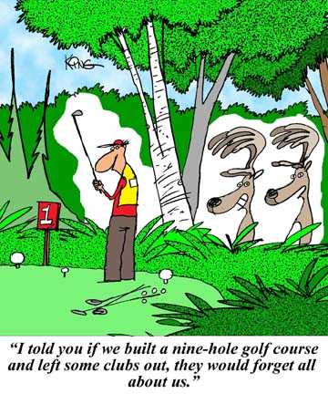

Great Picture of the Week

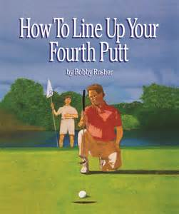

THAT'S ALL FOLKS

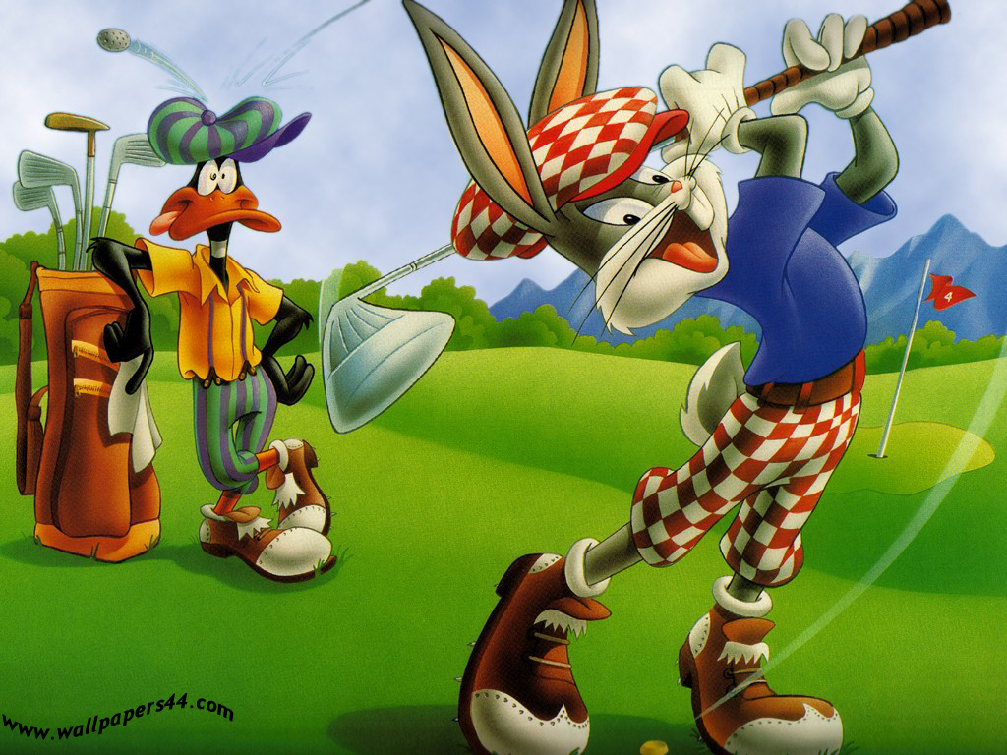

HAVE A GREAT ROUND

