NUWC Golf League Bulletin – 2nd Half
Week #12
25 July, 2013

Place |  | Team |  | 2nd Half Pts | 10 | 11 | 12 | 13 | 14 | 15 | 16 | 17 | 18
1 |  | 3 |  | 85.5 | 43.5 | 42 | P
2 |  | 1 |  | 84.5 | 41 | 43.5 | O
3 |  | 7 |  | 81 | 43.5 | 37.5 | S
4 |  | 8 |  | 71.5 | 35.5 | 36 | T
5 |  | 4 |  | 70.5 | 36.5 | 34 | P
6 |  | 2 |  | 70.5 | 36 | 34.5 | O
7 |  | 6 |  | 61 | 31 | 30 | N
8 |  | 9 |  | 57 | 28.5 | 28.5 | E
9 |  | 5 |  | 42.5 | 4.5 | 38 | D
Indicates Bye Week. The Bye Week team receives 36 points

RAINED OUT – MAKE-UP AT END OF SEASON

Birdie (or Better)Report:
Birdie Report
Name | Hole Number

News

RAINED OUT – MAKE-UP AT END OF SEASON

The END OF YEAR Tournament at Ledgemont is set for September 24th TUESDAY.
Put a Reminder in your Calendars

Reminder that the web page is back on line.
The Golf League Website is now at:
http://ngloob.com (NUWC Golf League - Out Of Bounds). Please use this new URL from now on for league info and sub requests!

Notes:

Captains should call/e-mail the handicapper, Pete Michno, no later than 1100 Thursday to give their line-ups. However, I’m sure the handicapper would appreciate Captains providing the line-ups earlier if you have them set. 1100 on Thursday should be the exception, not the rule.

Captains should inform all retirees and non-NUWC members on their teams to use the website for all League information (of course only from outside NUWC presently) or forward on news as appropriate.

Slow Play Watch:

Joke of the Week

Quote of the Week
Golf Cartoon of the Week
Great Pictures of the Week

Now these are some Golfers:
NUWC GOLF LEAGUE MASCOTS
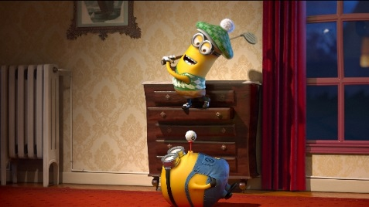

MATCH-UPS FOR WEEK 13
TEAM: |  |  |  |  |  |  | 1 |  |  | Points  84.5 |  | TEAM: |  |  |  |  |  |  | 7 |  |  | Points  81
Tee Time | # | Sub | POS | HND | NAME | GRS | ADJ | NET | PTS |  |  | Tee Time | # | Sub | POS | HND | NAME | GRS | ADJ | NET | PTS
2:46 F | 176 |  | 1A** | 8 | Chris Hillenbrand | 0 | 0 |  | 0 |  |  | 2:46 F | 118 |  | 7A | 9 | Ray Harnois | 0 | 0 |  | 0
 | 8 |  | 1A | 9 | Gino Cerbarano | 0 | 0 |  |  |  |  |  | 137 |  | 7A | 8 | Chris Egan | 0 | 0
4:22 F | 24 |  | 1B | 14 | Jim Mellin | 0 | 0 |  | 0 | Place  2 |  | 4:22 F | 22 |  | 7B | 9 | Barbara Keller | 0 | 0 |  | 0 | Place  3
 | 79 |  | 1B | 12 | John Brereton | 0 | 0 |  |  |  |  |  | 9 |  | 7B | 13 | Dave Sowersby | 0 | 0
3:50 F | 134 |  | 1C | 11 | Pierre Corriveau | 0 | 0 |  | 0 |  |  | 3:50 F | 113 |  | 7C | 14 | Ted Whittier | 0 | 0 |  | 0
 | 107 |  | 1C | 14 | Don Aker | 0 | 0 |  |  |  |  |  | 11 |  | 7C** | 16 | Tom Wilusz | 0 | 0
3:18 F | 143 |  | 1D | 18 | Marshall Lundberg | 0 | 0 |  | 0 |  |  | 3:18 F | 135 |  | 7D | 18 | Tom Matthews | 0 | 0 |  | 0
 | 197 |  | 1D | 19 | Joe Izzi | 0 | 0 |  |  |  |  |  | 174 |  | 7D | 19 | Robert LaTourette | 0 | 0
TEAM: |  |  |  |  |  |  | 3 |  |  | Points  85.5 |  | TEAM: |  |  |  |  |  |  | 2 |  |  | Points  34.5
Tee Time | # | Sub | POS | HND | NAME | GRS | ADJ | NET | PTS |  |  | Tee Time | # | Sub | POS | HND | NAME | GRS | ADJ | NET | PTS
2:54 F | 151 |  | 3A | 4 | Dan Schwab | 0 | 0 |  | 0 |  |  | 2:54 F | 170 |  | 2A | 10 | Matt Cieloszyk | 0 | 0 |  | 0
 | 62 |  | 3A** | 6 | Paul Dube | 0 | 0 |  |  |  |  |  | 18 |  | 2A** | 8 | Keith Casey | 0 | 0
4:30 F | 97 |  | 3B | 5 | George Bertsch | 0 | 0 |  | 0 | Place  1 |  | 4:30 F | 150 |  | 2B | 10 | Chris Anderson | 0 | 0 |  | 0 | Place  8
 | 178 |  | 3B | 13 | Brian Hodor | 0 | 0 |  |  |  |  |  | 32 |  | 2B | 14 | Ron Cirillo | 0 | 0
3:58 F | 67 |  | 3C | 12 | Glenn Donovan | 0 | 0 |  | 0 |  |  | 3:58 F | 140 |  | 2C | 15 | Phil Duckett | 0 | 0 |  | 0
 | 108 |  | 3C | 14 | Marc Coffland | 0 | 0 |  |  |  |  |  | 103 |  | 2C | 14 | John Patton | 0 | 0
3:26 F | 159 |  | 3D | 13 | Jin Lee | 0 | 0 |  | 0 |  |  | 3:26 F | 162 |  | 2D | 15 | Ken Pietrzak | 0 | 0 |  | 0
 | 198 |  | 3D | 21 | Charles Beltz | 0 | 0 |  |  |  |  |  | 15 |  | 2D | 20 | Jeff Watrowski | 0 | 0
TEAM: |  |  |  |  |  |  | 5 |  |  | Points  42.5 |  | TEAM: |  |  |  |  |  |  | 9 |  |  | Points  57
Tee Time | # | Sub | POS | HND | NAME | GRS | ADJ | NET | PTS |  |  | Tee Time | # | Sub | POS | HND | NAME | GRS | ADJ | NET | PTS
2:30 F | 27 |  | 5A | 7 | Romeo Velasco | 0 | 0 |  | 0 |  |  | 2:30 F | 45 |  | 9A** | 7 | Tim Fratus | 0 | 0 |  | 0
 | 49 |  | 5A | 10 | Mitch Krzyzek | 0 | 0 |  |  |  |  |  | 188 |  | 9A | 12 | Tom Dunn | 0 | 0
4:06 F | 167 |  | 5B | 11 | Rich Bashour | 0 | 0 |  | 0 | Place  6 |  | 4:06 F | 156 |  | 9B | 12 | Tom Powden | 0 | 0 |  | 0 | Place  6
 | 26 |  | 5B | 13 | Mark Zingarelli | 0 | 0 |  |  |  |  |  | 21 |  | 9B | 15 | Charlie Walsh | 0 | 0
3:34 F | 96 |  | 5C | 11 | Hugh Murphy | 0 | 0 |  | 0 |  |  | 3:34 F | 173 |  | 9C | 12 | Louis Krzych | 0 | 0 |  | 0
 | 37 |  | 5C | 12 | John Perry | 0 | 0 |  |  |  |  |  | 191 |  | 9C | 15 | Pete Hill | 0 | 0
3:02 F | 73 |  | 5D** | 14 | Pete Decoste | 0 | 0 |  | 0 |  |  | 3:02 F | 157 |  | 9D | 16 | Sean Riccio | 0 | 0 |  | 0
 | 75 |  | 5D | 22 | Morgan Bailey | 0 | 0 |  |  |  |  |  | 158 |  | 9D | 24 | Sandra Richardson | 0 | 0
TEAM: |  |  |  |  |  |  | 6 |  |  | Points  61 |  | TEAM: |  |  |  |  |  |  | 8 |  |  | Points  35.5
Tee Time | # | Sub | POS | HND | NAME | GRS | ADJ | NET | PTS |  |  | Tee Time | # | Sub | POS | HND | NAME | GRS | ADJ | NET | PTS
2:38 F | 153 |  | 6A | 5 | Tod Camara | 0 | 0 |  | 0 |  |  | 2:38 F | 154 |  | 8A | 10 | Neil Jackson | 0 | 0 |  | 0
 | 41 |  | 6A** | 10 | Peter Michno | 0 | 0 |  |  |  |  |  | 155 |  | 8A | 7 | Dale Dandrea | 0 | 0
4:14 F | 7 |  | 6B | 10 | Bob Iriye | 0 | 0 |  | 0 | Place  5 |  | 4:14 F | 213 |  | 8B | 7 | Tony Caldwell | 0 | 0 |  | 0 | Place  7
 | 14 |  | 6B | 15 | Jim Paiva | 0 | 0 |  |  |  |  |  | 128 |  | 8B | 13 | Bob Albanese | 0 | 0
3:42 F | 31 |  | 6C | 12 | Dave Nassaney | 0 | 0 |  | 0 |  |  | 3:42 F | 1 |  | 8C | 14 | Mike Huggins | 0 | 0 |  | 0
 | 122 |  | 6C | 15 | Ray Malone | 0 | 0 |  |  |  |  |  | 16 |  | 8C** | 16 | Jay Snoke | 0 | 0
3:10 F | 192 |  | 6D | 18 | Tom Richards | 0 | 0 |  | 0 |  |  | 3:10 F | 43 |  | 8D | 18 | John Mcneil | 0 | 0 |  | 0
 | 82 |  | 6D | 17 | Scott Hassan | 0 | 0 |  |  |  |  |  | 2 |  | 8D | 20 | Steve Masterson | 0 | 0
THAT'S ALL FOLKS

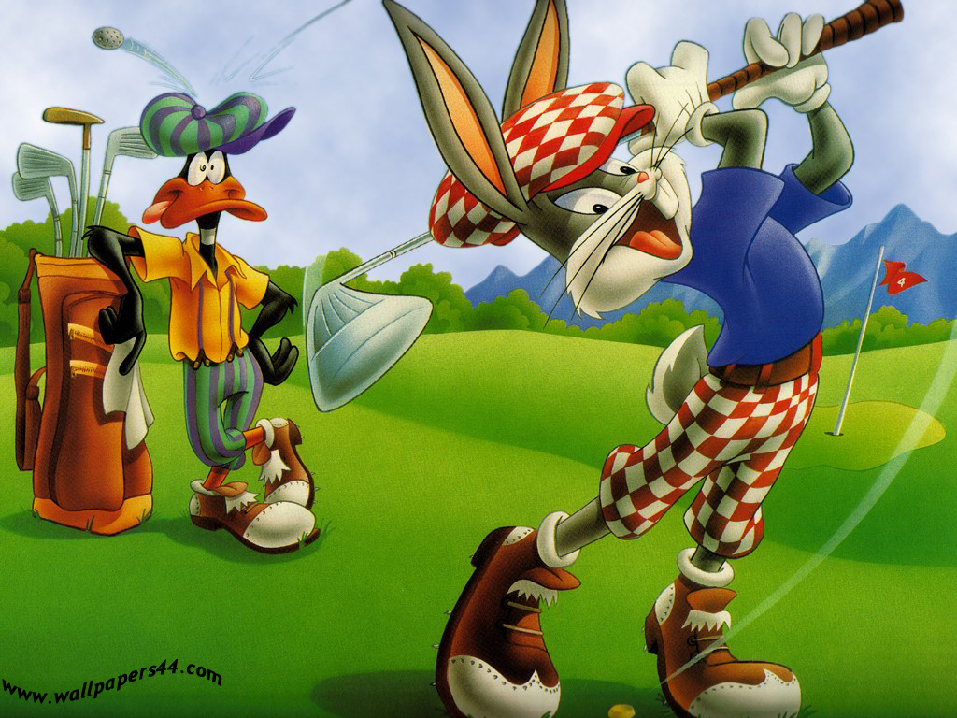

HAVE A GREAT ROUND

